Customer Shopping Behavior Analysis

1. Project Overview
The Customer Shopping Behavior Analysis project examines transactional data from 3,900 customer purchases to understand shopping patterns, customer preferences, and purchasing behavior. The analysis aims to generate actionable insights that help businesses make informed decisions related to marketing strategies, customer retention, product performance, and revenue growth.
The project follows a complete data analytics workflow, including data cleaning and preprocessing using Python, business analysis using PostgreSQL, and interactive visualization through Power BI.

2. Business Objective
The primary objective of this project is to provide a comprehensive understanding of customer shopping behavior by analyzing revenue trends, purchasing patterns, customer demographics, product preferences, discount usage, and subscription behavior. These insights enable businesses to optimize marketing strategies, improve customer engagement, and support data-driven decision-making.

3. Dataset Summary
The analysis was performed using a customer shopping dataset consisting of 3,900 records and 18 attributes.

Dataset Details
Attribute | Description
Number of Records | 3,900
Number of Columns | 18
Data Source | Customer Shopping Trends Dataset
Database | PostgreSQL
Programming Language | Python
Visualization Tool | Power BI

Key Features
The dataset includes information related to:
- Customer Demographics
  - Age
  - Gender
  - Location
  - Subscription Status
- Purchase Information
  - Item Purchased
  - Category
  - Purchase Amount
  - Season
  - Size
  - Color
- Shopping Behavior
  - Discount Applied
  - Promo Code Used
  - Previous Purchases
  - Purchase Frequency
  - Review Rating
  - Shipping Type

Missing Values
The Review Rating column contained 37 missing values, which were handled during data preprocessing.

4. Data Cleaning and Preprocessing (Python)
The dataset underwent several preprocessing steps to ensure data quality and consistency before analysis.

Data Loading
The dataset was imported into Python using the Pandas library.

Initial Data Exploration
The dataset structure and statistical summary were examined using:
- df.info()
- df.describe()
- df.head()
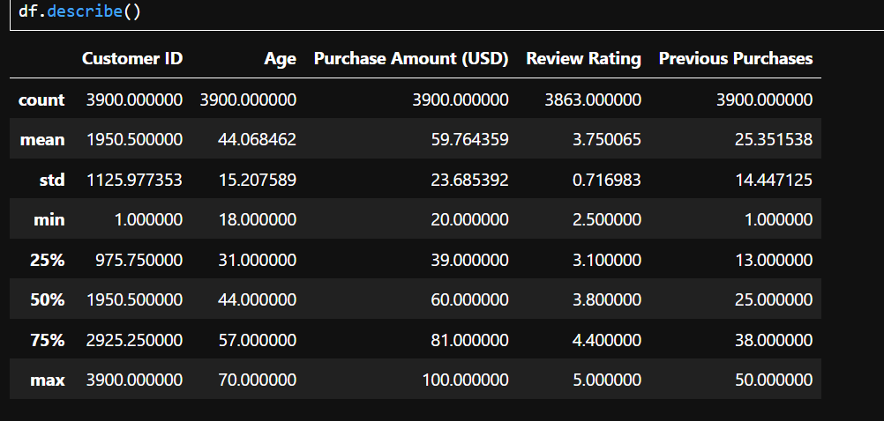

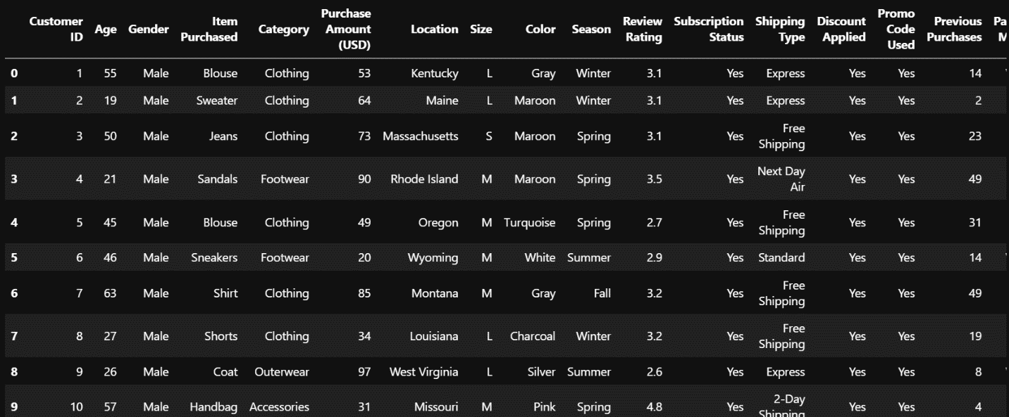

Missing Value Treatment
The missing values in the Review Rating column were replaced using the median review rating within each product category, preserving category-specific rating distributions.

Column Standardization
Column names were converted into snake_case format to improve readability and maintain SQL compatibility.

Feature Engineering
Two additional features were created:
- Age Group – Customers were grouped into age categories.
- Purchase Frequency (Days) – Purchase frequency was converted into numerical values for easier analysis.

Data Consistency Check
The relationship between Discount Applied and Promo Code Used was examined. Since the two fields contained redundant information, the Promo Code Used column was removed.

Database Integration
The cleaned dataset was connected to PostgreSQL using SQLAlchemy and loaded into the database for further SQL analysis.

5. Business Analysis Using SQL
The cleaned dataset was analyzed using PostgreSQL to answer key business questions and identify meaningful customer insights.
The following analyses were performed:

Revenue Analysis
- Compared total revenue generated by male and female customers.
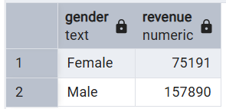
- Calculated revenue contribution by different age groups.
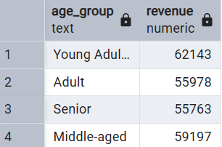

Customer Spending Analysis
- Identified customers who used discounts while spending above the average purchase amount.
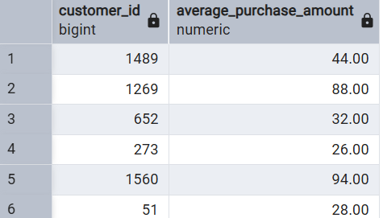
- Compared average spending between subscribers and non-subscribers.
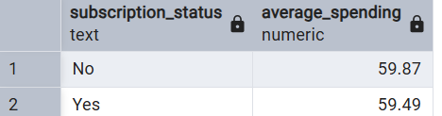

Product Performance Analysis
- Identified the top five highest-rated products.
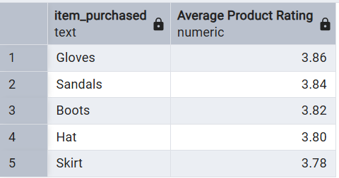
- Determined the top three most-purchased products within each product category.
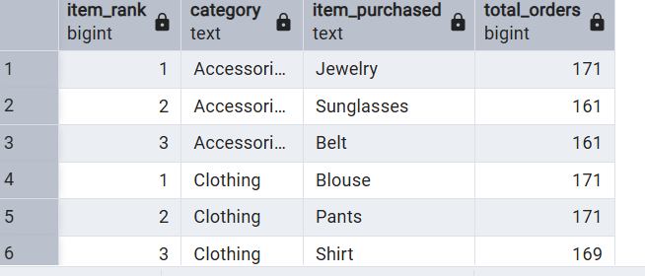

Shipping Analysis
- Compared average purchase amounts across different shipping methods.
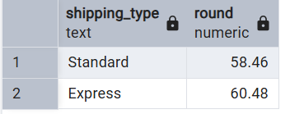

Discount Analysis
- Identified products with the highest percentage of discounted purchases.
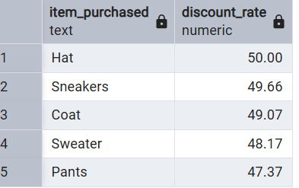

Customer Segmentation
Customers were classified into three groups based on previous purchases:
- New Customers
- Returning Customers
- Loyal Customers
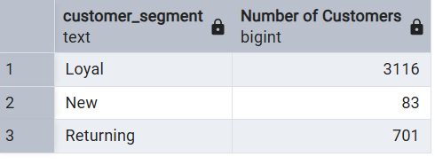

Subscription Analysis
Analyzed whether customers with more than five previous purchases were more likely to subscribe.
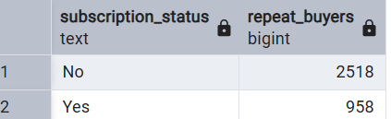

6. Dashboard Development (Power BI)
An interactive Power BI dashboard was created to visualize business insights effectively.
The dashboard includes:
- Revenue Overview
- Customer Demographics
- Purchase Trends
- Product Category Performance
- Subscription Analysis
- Discount Analysis
- Shipping Analysis
- Customer Segmentation
- Interactive Filters and Slicers
- KPI Cards
The dashboard enables users to explore customer behavior dynamically and make informed business decisions through interactive visualizations.

7. Key Findings
The analysis revealed several valuable insights:
- Subscribers contributed significantly higher overall revenue compared to non-subscribers.
- Loyal customers accounted for a large share of total purchases.
- Certain products relied heavily on discounts to increase sales.
- Customers selecting express shipping generally recorded higher purchase values.
- A small number of products consistently ranked among the highest in both sales and customer ratings.
- Adult and young adult customers generated the majority of overall revenue.

8. Business Recommendations
Based on the analysis, the following recommendations are proposed:
- Increase Subscription Adoption by offering exclusive discounts, rewards, and premium benefits.
- Strengthen Customer Loyalty Programs to encourage repeat purchases and retain valuable customers.
- Optimize Discount Strategies to improve profitability while maintaining customer engagement.
- Promote Top-Rated Products through targeted marketing campaigns and personalized recommendations.
- Focus Marketing Efforts on high-revenue customer segments and age groups.
- Encourage Premium Shipping Options by highlighting faster delivery benefits for high-value customers.

9. Tools and Technologies
Technology | Purpose
Python | Data Cleaning & Preprocessing
Pandas | Data Manipulation
SQLAlchemy | Database Connectivity
PostgreSQL | SQL Analysis
Power BI | Dashboard Development
Git & GitHub | Version Control

10. Conclusion
This project demonstrates an end-to-end data analytics workflow, beginning with data preprocessing in Python, followed by business analysis in PostgreSQL, and concluding with interactive visualizations in Power BI. The insights generated from this analysis help organizations better understand customer purchasing behavior, identify high-value customer segments, improve marketing strategies, and support data-driven business decisions.

Prepared By:
Deepika Layek
Data Analyst | Python | SQL | Power BI | PostgreSQL

